**UTA MARKETPLACE**

Market Place for students of The University of Texas, Arlington

CSE-5324-003

SOFTWARE ENGINEERING 1 ANALYSIS, DESIGN, TESTING

Group Name: SCRUM

Group 14

Date: 11/02/2022

**Team Members:**

Manali Gandhi: 1002084355

Gaurav Taneja: 1001955801

Divya Darshi: 1002090905

Akash Upadhyay: 1001957955

**TABLE OF CONTENT**

|  |
| --- |
|  |

**Project Summary**

The purpose of the Marketplace system is to take advantage of the internet to improve the private way where millions of items can be traded daily. The Online Marketplace provides a platform where registered users can buy and sell products or items online. The system has four types of users: Admin, Buyer, Seller, and Visitor. Sellers can upload any item on the site to sell it. The administration is responsible for authenticating users and products.

**Some important key features of UTA Marketplace are as follows:**

1. **Sign up**: The first step as a user is to sign up for the application. This page will ask for certain basic information such as name, phone number, UTA email ID and UTA ID, password, etc.
2. **Login**: Once the user’s email is verified, they can log in to the application to buy or sell. This functionality solves the issue of unauthorized users.
3. **Logout**: The app will allow the user to log out from the system to clear the user’s session.
4. **Forgot password:** The user can click on the forget password link on the login page to get a link to their registered mail.
5. **Home/View Items:** This feature will help the users to view the items.
6. **Purchase Items:** This feature will help the users to buy items.
7. **Sell Items:** This feature will help the users to sell the items.
8. **Favorite**: This feature will help the user to add items to the favorite list which will be maintained in the application
9. **GPS**: This feature helps in knowing the location of the user. This will aid in either

picking up or delivering the item to the user.

1. **Chat**: This feature will provide users to interact with each other. This will enable users to

get more information about the product and even negotiate the price of the item.

The user can verbally come to a contract about buying the product.

**REQUIREMENTS:**

|  |  |
| --- | --- |
| **RQRD ID** | **REQUIREMENT SYSTEM** |
| **R1** | The system shall allow users to register themselves. |
| **R2** | The system shall allow authenticated users to log in after registration. |
| **R3** | The system shall allow authenticated users to log out after a successful login session. |
| **R4** | The system shall allow the user to reset the password if forgotten. |
| **R5** | The system shall allow the users to view the items. |
| **R6** | The system shall allow the users to buy the items. |
| **R7** | The system shall allow the users to sell the items. |
| **R8** | The system shall offer users to add items to their favorite list. |
| **R9** | The system shall allow the users to view the location of the items. |
| **R10** | The system shall allow the user to chat with sellers and buyers. |

**Functional Requirements:**

Administration Module

* Admin can provide a username, email, password, and admin account Created.
* After logging in, there is a dashboard where admins can see the number of customers, the number of products sold, and the number of orders placed.
* Administrators can add/delete/view/edit products.
* Administrators can view/edit/delete customer data.
* Administrators can view/delete orders.
* Administrators can change the status of an order (order is pending, confirmed, in preparation for delivery, or delivered)

Users Module

* Users can view/search products after logging in.
* Users can also sell their products.
* Users can also add/remove products to the cart.
* When a user tries to purchase a product, they must log into the system.
* You can place an order after creating an account and logging into the system.
* The payment is successful when the user clicks the Pay button.
* Users can view order details by clicking the Orders button.
* Users can see the status of each order (pending, confirmed, shipped).

**Non-Functional Requirements:**

Specifies the quality features of the software system. they judge software systems based on their responsiveness, usability, security, portability, and other non-functional criteria Critical to the success of any software system.

* Availability:

Systems need to stay up and running every day, everywhere.

* Accuracy:

The system needs to be fine-tuned to ensure more accurate results and calculations.

* Usability:

The system should provide a user-friendly interface and tooltips for improvement Respond effectively and independently.

* Security:

The system should be able to provide security against external injection multi-layer security systems. Also, the implementation of the user login function ensures that the system is Protected from unauthorized persons.

* System Performance:

Response times are particularly good for the work given. the system Support multi-user environments.

* System Reliability:

The system is very reliable and produces all updated Information in the correct order. Data validation and verification are done at every stage of the activity.

**Interface Requirements:**

This section describes the necessary hardware components and software requirements. Effective and efficient operation of the system.

Hardware Interfaces:

Laptop

* Core i5 or i7
* Hard Disk
* 1TBMinimum 4GB RAM

Software Interfaces:

* Windows or Mac
* Android studio
* ADT Bundle XAMPP Server (Apache & MySQL)
* Java Development Kit

**USE CASE LIST:**

**HIGH-LEVEL USE CASE:**

UC 1: Register

* TUCBW the new user clicking on Register to create an account.
* TUCEW user creating an account to store items in the to-do list.

UC 2: Login

* TUCBW the user clicking on Login to login into an existing account.
* TUCEW user logging into the existing account.

UC 3: Logout

* TUCBW the user clicking on Logout to log out from the account.
* TUCEW user logs out from the account.

UC 4: Forget Password

* TUCBW the user clicking on the forget option to reset the password.
* TUCEW user gets a new password to log in.

UC 5: Home/View Items

* TUCBW the user clicking on Home to view items.
* TUCEW user viewing new items.

UC 6: Purchase Items

* TUCBW the user clicks on Purchase items.
* TUCEW users buy the items.

UC 7: Sell Items

* TUCBW the user clicks on Sell items.
* TUCEW users sell the items.

UC 8: Favorite

* TUCBW the user clicks on Favorite.
* TUCEW user gets to view items on their favorite.

UC 9: GPS

* TUCBW the user clicks on a GPS.
* TUCEW user gets to view the location of items.

UC 10: Chat

* TUCBW the user clicks on chat.
* TUCEW the buyer and seller chat with each other.

**USE CASE DIAGRAM:**

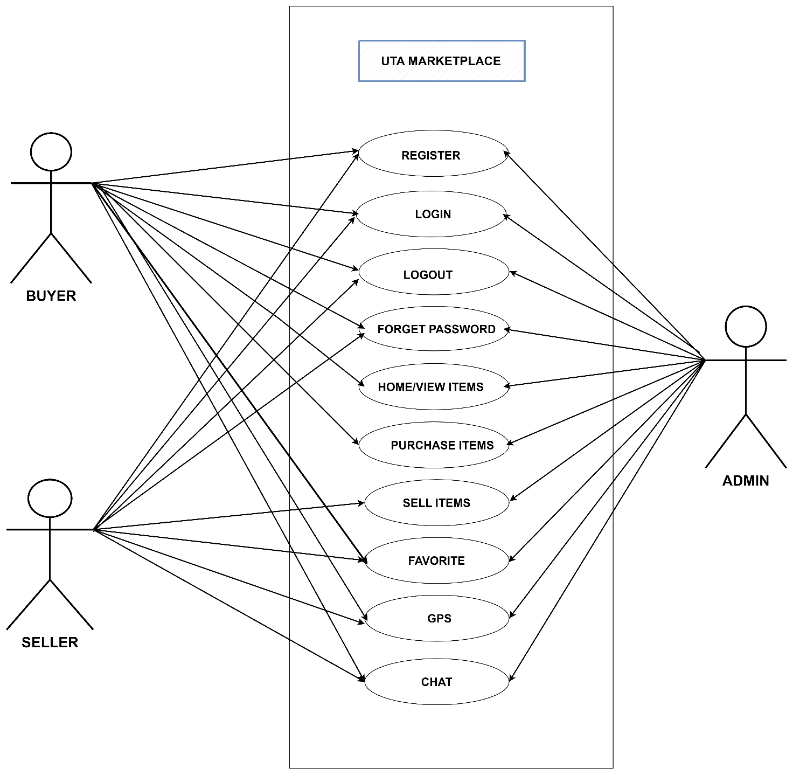

**EXPANDED USE CASE:**

|  |  |
| --- | --- |
| UC1: REGISTER | |
| **Pre-Condition: None** |  |
| **Actor: User** | **System: UTA MARKETPLACE** |
|  | **0. System displays login form screen.** |
| **1. TUCBW user clicking on the “Sign Up” button.** | **2. System displays the registration form to the user.** |
| **3. The user fills out the registration form and presses submit button.** | **4. The system displays success if registration is successful or an error message if registration fails for the user.** |
| **5. TUCEW user sees the "Successfully Registered" message and gets successfully registered to the application else will see the error message.** |  |
| **Post Condition: None** | |
| **EUC2: LOGIN** | |

**EUC1: REGISTER**

|  |  |
| --- | --- |
| **UC2: LOGIN** | |
| **Pre-Condition: The user must be registered in the application.** | |
| **Actor: User** | **System: UTA MARKETPLACE** |
|  | **0. System displays the login form screen.** |
| **1. TUCBW user fills out the login form and presses the “Login” button.** | **2. The system displays success if login is successful or an error message if login fails the user.** |
| **3. TUCEW user sees a success message and gets redirected to the home screen if login is successful else will see the error message.** |  |
| **Post Condition: None** |  |

**EUC3: LOGOUT**

|  |  |
| --- | --- |
| **UC2: LOGOUT** | |
| **Pre-Condition: The user must be logged into the application** | |
| **Actor: User** | **System: UTA MARKETPLACE** |
|  | **0. System displays the homepage.** |
| **1. TUCBW user clicks on the Hamburger menu (three horizontal lines) in the toolbar and clicks on the logout button.** | **2. The system shall end the user’s session and return to the login screen with a “Logged out” message.** |
| **3. TUCEW user views login screen.** |  |
| **Post Condition: The user shall see the login page.** | |
|  | |

**EUC4: FORGET PASSWORD**

|  |  |
| --- | --- |
| **UC4: FORGET PASSWORD** | |
| **Pre-Condition: The user must be registered in the application.** | |
| **Actor: User** | **System: UTA MARKETPLACE** |
|  | **0. System displays a login page.** |
| **1. TUCBW user clicks on the “Click Here” view to go visit the Reset Password screen.** | **2. System redirects the user to the reset password form screen.** |
| **3. The user enters the email address and clicks on Send Code button to receive the code via email.** | **4. System authenticates the email address, if correct, generates a unique code, and sends it to the user’s email. The system now displays fields to enter generated code and new password to the user on the same screen.** |
| **5. User shall enter the code received via email and the new password in the fields shown on the Reset Password screen and Submit entries.** | **6. System verifies the code and displays the message “Password Updated”.** |
| **5. TUCEW user views the updated password message** |  |
| **Post Condition: The user shall return to a login screen.** | |

**EUC5: HOME/VIEW**

|  |  |
| --- | --- |
| **UC5: HOME/VIEW** | |
| **Pre-Condition: The user must be logged into the application** | |
| **Actor: User** | **System: UTA MARKETPLACE** |
|  | **0.** **The system displays all lists on the homepage** |
| **1. TUCBW user clicks on View Items.** | **2. System displays the item list.** |
| **3. TUCEW user views the items list.** |  |
| **Post-Condition: The user shall view the item list.** | |

**EUC6: PURCHASE ITEMS**

|  |  |  |
| --- | --- | --- |
| **UC6:** **PURCHASE ITEMS** | | |
| **Pre-Condition: The user must be logged into the application** | | |
| **Actor: Buyer** | | **System: UTA Marketplace** |
| **1. The Buyer adds his email and password and clicks on the login button** | | **0. The system displays a login page** |
| **2. The system verifies the details and redirects the user to the homepage.** |
| **3. The buyer explores the item from the homepage and selects any item he wants to buy** | | **4. The system shows the details for a specific item.** |
| **5. a) Buyer can click on buy option**  **b) Buyer can click on chat with a seller option** | **6. a) System will redirect to the checkout page**  **b) System will redirect to the chat page with a specific seller.** | |
| **Post Condition: Buyer shall buy the items.** | | |
| **EUC7: SELL ITEMS**   |  |  | | --- | --- | | **UC7: SELL ITEMS** | | | **Pre-Condition: The user must be logged into the application** | | | **Actor: Seller** | **System: UTA Marketplace** | |  | **0.The system displays the login page** | | **1. Seller adds his email and password and clicks on the login button** | **2. The system verifies the details and redirects the user to the homepage.** | | **3. The seller clicks on add item button** | **4. The system displays the list of distinct categories of items** | | **5. Seller can choose any category** | **6. System will redirect the seller to enter the item details.** | | **7. The seller will click on the sell item button** | **8. The system will add the item to the database and will be available for buyers to buy.** | | **Post Condition: The Seller shall sell the items.** | |   **EUC8: FAVORITE**   |  |  | | --- | --- | | **UC8: FAVORITE** | | | **Pre-Condition: The user must be logged into the application** | | | **Actor: User** | **System: UTA Marketplace** | |  | **0. The system displays all lists on the homepage** | | **1.TUCBW the user clicks on Favorite** | **2. System display the favorite items** | | **3. TUCEW user gets to view items on their favorite.** |  | | **Post Condition: The user shall see the favorite page.** | |     **EUC9: GPS**   |  |  | | --- | --- | | **UC9: GPS** | | | **Pre-Condition: The user must be logged into the application** | | | **Actor: User** | **System: UTA MARKETPLACE** | |  | **0. The system displays all lists on the homepage** | | **1. TUCBW the user clicks on a GPS.** | **2. System displays the location of items** | | **3. TUCEW user gets to view the location of items.** |  | | **Post Condition: The user shall see the location of items.** | |   **EUC10: CHAT**   |  |  | | --- | --- | | **UC10: CHAT** | | | **Pre-Condition: The user must be logged into the application** | | | **Actor: User** | **System: UTA MARKETPLACE** | |  | **0. The system displays all lists on the homepage** | | **1. TUCBW the user clicks on chat.** | **2. System displays the chat box** | | **3. TUCEW user chats with Seller/Buyer.** |  | | **Post Condition: The buyer and seller chat with each other.** | |     **DOMAIN MODEL:**        **SEQUENCE DIAGRAM:** **Incremental Matrix:** | | |
|  | | |

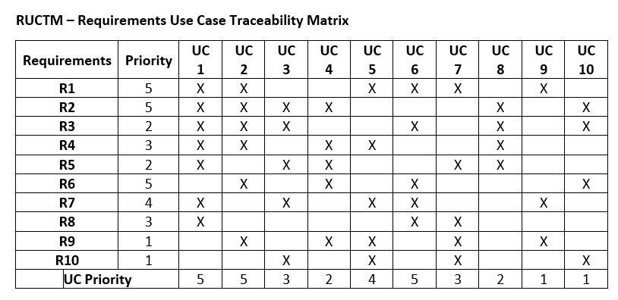

**Team Size – 4**

**Reasons for Dependency:**

**UC1** – This is the solo Use Case with no dependency

**UC2** – Dependent on UC1 as Registration is necessary for logging in to the application

**UC3** – Dependent on UC2 as the user needs to be logged in to the application

**UC4** – Dependent on UC1 as the user will set a password during registration and the same information will then be used to verify his credentials upon clicking Forgot Password

**UC5** – Dependent on UC2 as to get to the home page of the application a user needs to be logged in

**UC6** – To purchase an item through our application, the user will need to log in which in turn makes it dependent on UC2

**UC7** – For selling an item, the user will have to be logged in to our application. Hence dependence on UC2

**UC8** – Once logged in, the user can check any item as Favorite from the home page. Therefore, this makes dependence on both UC1 and UC5

**UC9** – This is the solo Use Case with no dependency

**UC10** – Lastly, to access our Chat feature, a user must be logged in to the application. Thus, dependence on UC2

**USER INTERFACE PROTOTYPES:**

**REGISTER**

**SIGN-UP**

**LOGIN**

**HOME SCREEN**

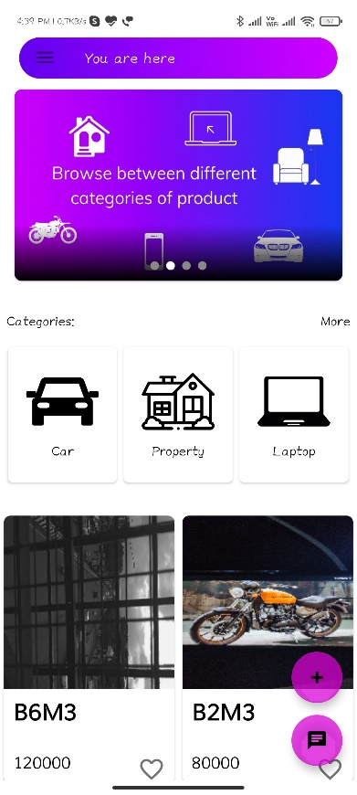

**FAVORITES:**

**CATEGORY NAVIGATION**

**CHANGE PASSWORD NAVIGATION:**

